DolFin_New Development Environment Setup and Configuration



|  |  |
| --- | --- |
| **Document title** | DolFin Development Environment Setup and Configuration |
| **Contact details** | [databytes@deakin.edu.au](mailto:databytes@deakin.edu.au) |
| **Approved by** | Junkai Jiang |
| **Date approved** | 24/05/24 |
| **Document review** | Each Trimester or As Required |

|  |  |  |  |
| --- | --- | --- | --- |
| Version | Date | Author | Changes made |
| 0.1 | 25/05/2024 | Deepak Kumar Khatri | Initial draft documenting configuration procedure for the local deployment |

|  |  |  |  |
| --- | --- | --- | --- |
| **Document Sign Off** | | | |
| **Name** | **Role** | **Signature** | **Date** |
| Junkai Jiang | Senior Leadership (T1 ‘24) | J.Jiang | 24/05/2024 |
|  |  |  |  |

|  |  |
| --- | --- |
| **Reviewers** | |
| **Name** | **Role** |
| Junkai Jiang | Senior Leadership (T1 ‘24) |
|  |  |

Table of Contents

1. Introduction 4

1.1. Background 4

1.2. Purpose 4

1.3. Dependencies 4

2. Configuration Procedure – Local Deployment 5

3. Document Acronyms and References 12

3.1. Acronyms 12

3.2. References 12

# Introduction

## Background

DolFin is a Fintech solution that aims to address the issue of people struggling to keep track of their finances, the difficulties and costs associated with obtaining financial advice, banks acting monopolistically and traditional banking not serving people equally.

The project aims to use open banking data to display all financial accounts held by an individual and provide a high-level summary, detailed reporting and graphs/visual diagrams of this data on a website and mobile platform. This will help educate people of their financial situation.

DolFin also provides customized advice using an AI prediction model and a chatbot. The AI prediction model allows for an individual’s financial data to be analysed to provide savings predictions and comparisons to others in similar situations. It is possible a recommendation AI model could be added in later trimesters, to allow for credit card/bank account/interest rate suggestions.

## Purpose

This document outlines the steps required to be undertaken by students to implement a local version of the development environment on their own device. This document is based on the NEO DolFin GitHub implementation located in the following repository: <https://github.com/DataBytes-Organisation/Dolfin_new>

## Dependencies

A Macbook Pro M2 Professional Device was used to implement and configure the development environment when creating this document.  
The following dependencies were required and should be downloaded and installed prior to undertaking the steps in the next section.

|  |  |
| --- | --- |
| Dependency | Website / Download Location |
| Python 3.11 | <https://www.python.org/downloads/release/python-3110/> |
| GiTHub Desktop Note: Students are recommended to use GitHub Desktop for source control in the DolFin project. | <https://desktop.github.com/> |
| IDE – Visual Studio Code Note: alternative IDE’s may be used. Various DolFin team members are using Visual Studio Code which is freely available and demonstrated when to drafting this manual | <https://code.visualstudio.com/download> |
| Docker – Docker is used create the images to run the project in Producttions Enviroment | <https://www.docker.com/products/docker-desktop/> |
| MongoDb and MongoDb Compass | <https://www.mongodb.com/try/download/community><https://www.mongodb.com/products/tools/compass> |

# Configuration Procedure – Local Deployment

1. In a Web Browser navigate to the following address:   
   <https://github.com/DataBytes-Organisation/Dolfin_new>
2. On the Neo_DolFin GitHub webpage click on the **Code** button to expand the menu then click on the **Open with GitHub Desktop**.
3. If presented with a similar popup window as shown below. Click on the **Open GitHubDesktop.exe** button.

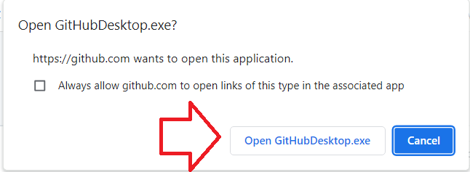

1. GitHub Desktop will now open with the repository URL already populated.   
   Ensure that the **local path** is on a suitable location on your local device and click the **Clone** button.

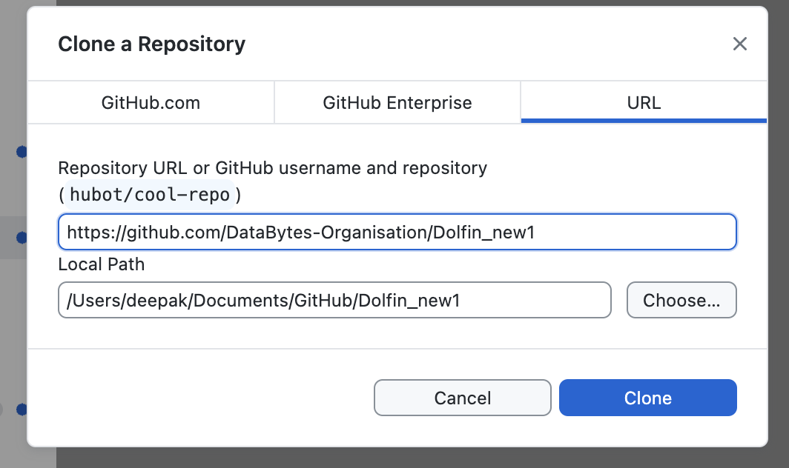

1. A clone of the DolFin Neo repository will now be located and monitored under source control on your device and can be accessed via the location that was entered in the **Local path** for your device.

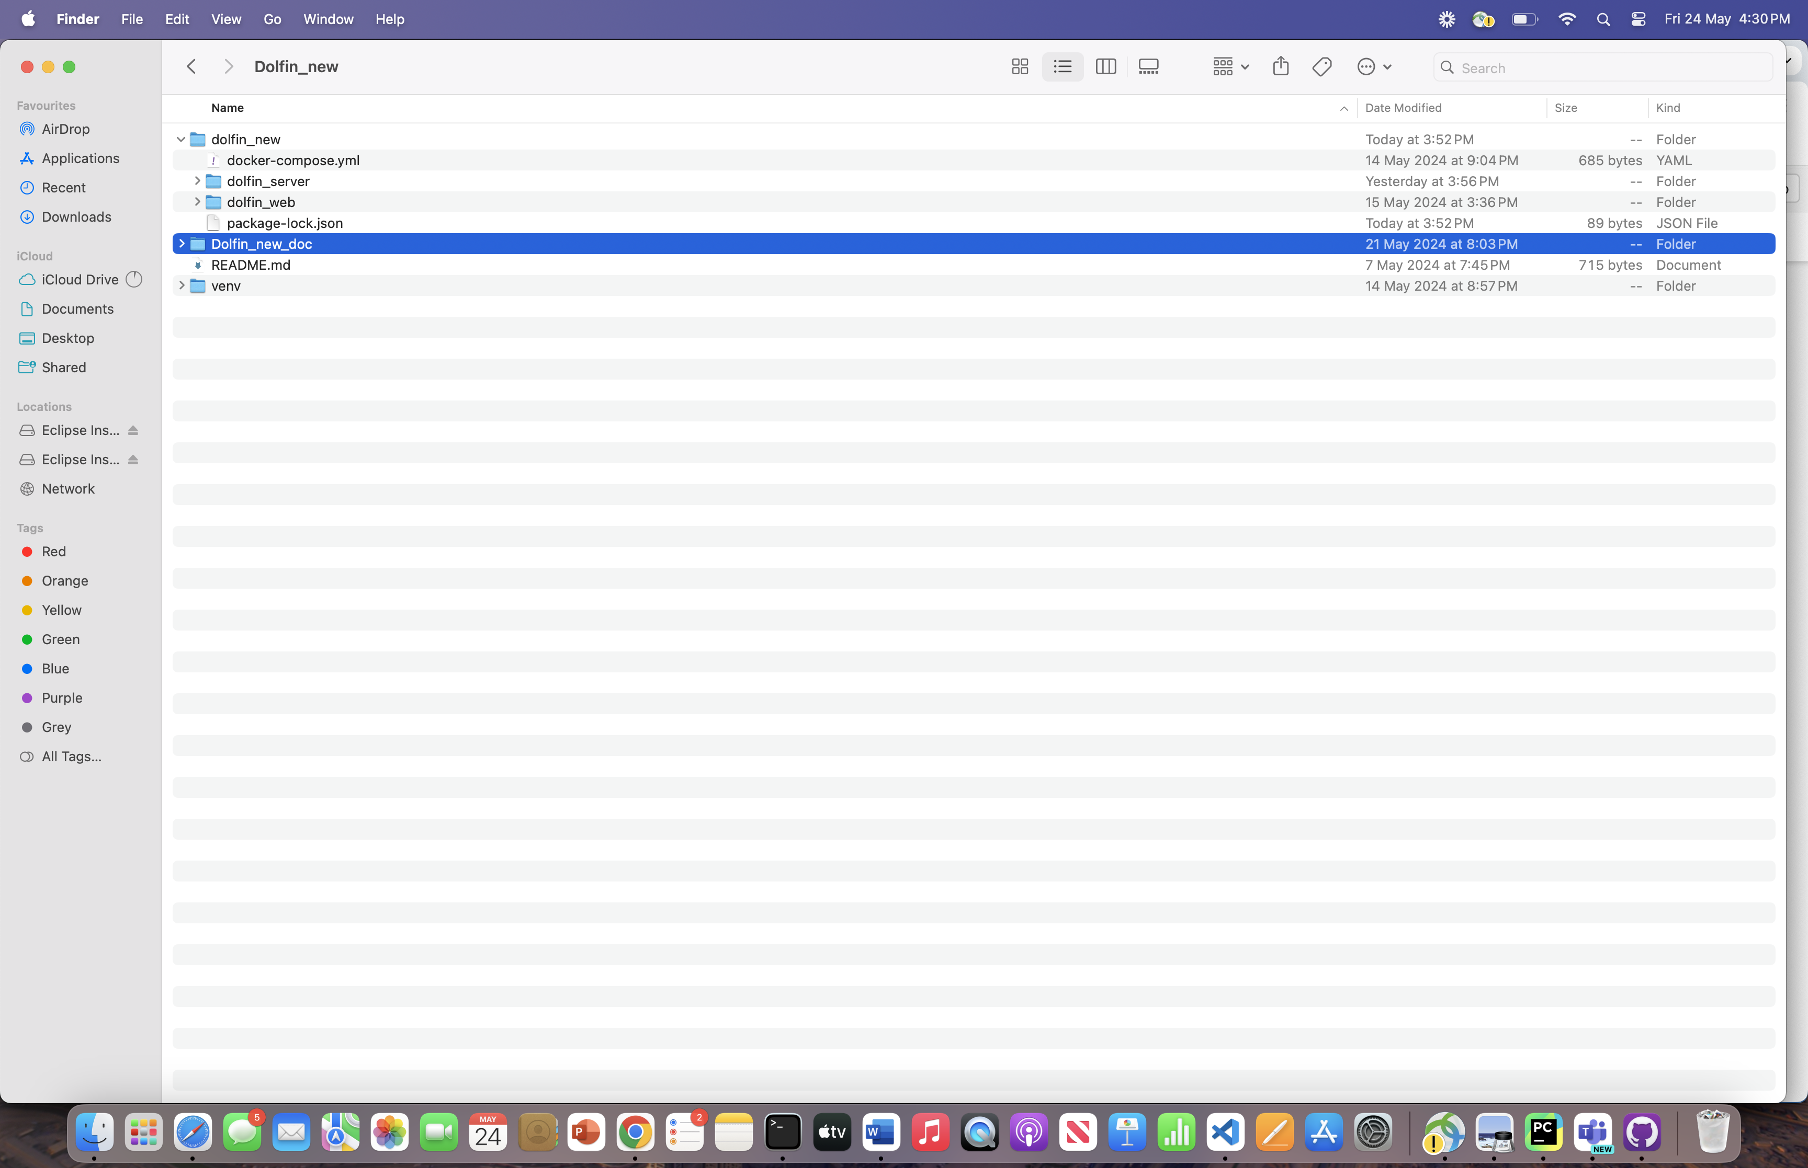

1. Open the **Visual Studio Code** IDE and click on the **Explorer** Icon located at the top left of the page, then click the **Open Folder** button.

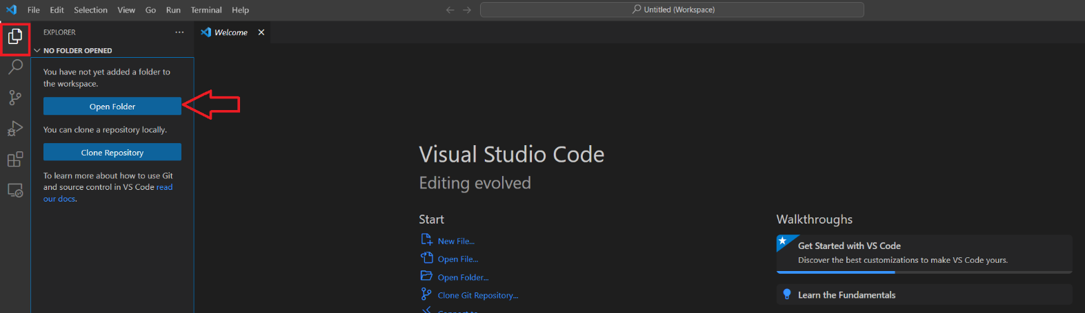

1. Navigate to the directory where you created your **local path** in GitHub Desktop and click the **Add** button. Following Image can be used as reference

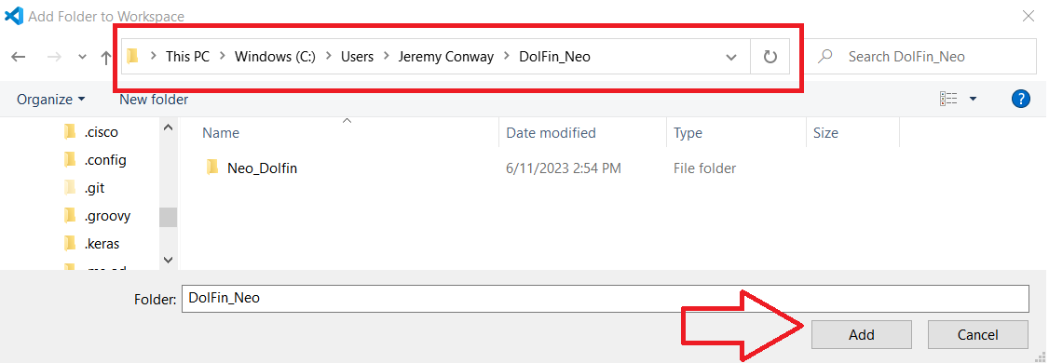

1. When presented with the following dialog window click on the **Save** button so that this workspace will be available in future sessions when using Visual Studio Code.

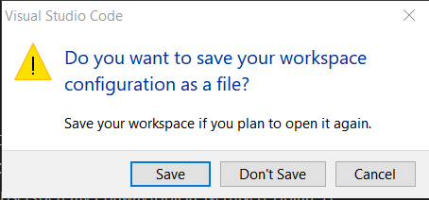

1. If you expand the **DOLFIN_NEO** tree structure in the explorer tab you will now be able to view, create new files and exit exiting code under the **develop** branch.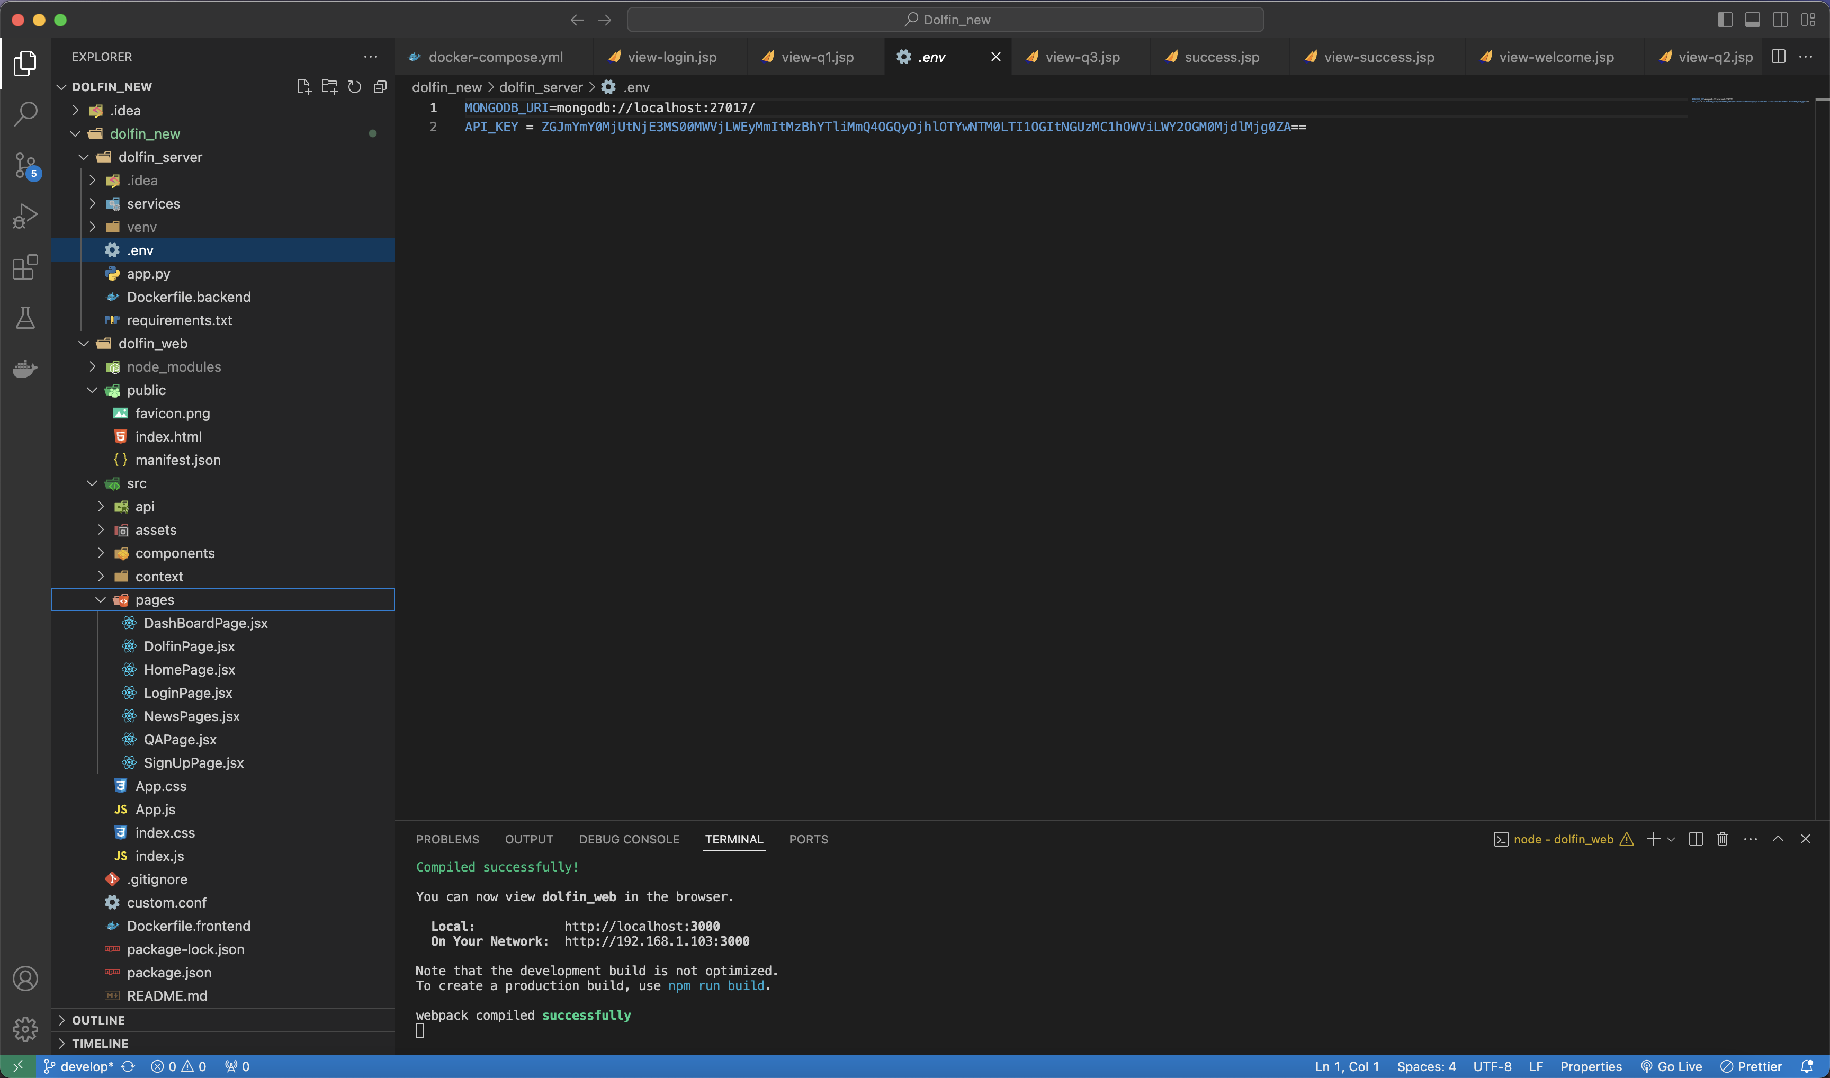.

You are now connected to the DolFin GitHub repository, setup with source control managed via GitHub Desktop and can use Visual Studio Code to commence coding. The following steps are the procedures on how to start your local virtual environment to interact with the DolFin application.

To Run Dolfin New, there are multiple ways.

* Production Enviroment.
  + Once the Docker is downloaded and is running on your system, just follow:

navigate to Dolfin_New/dolfin_new using terminal:

cd dolfin_new

docker-compose up.

Note: Make sure Docker Desktop is up and running.

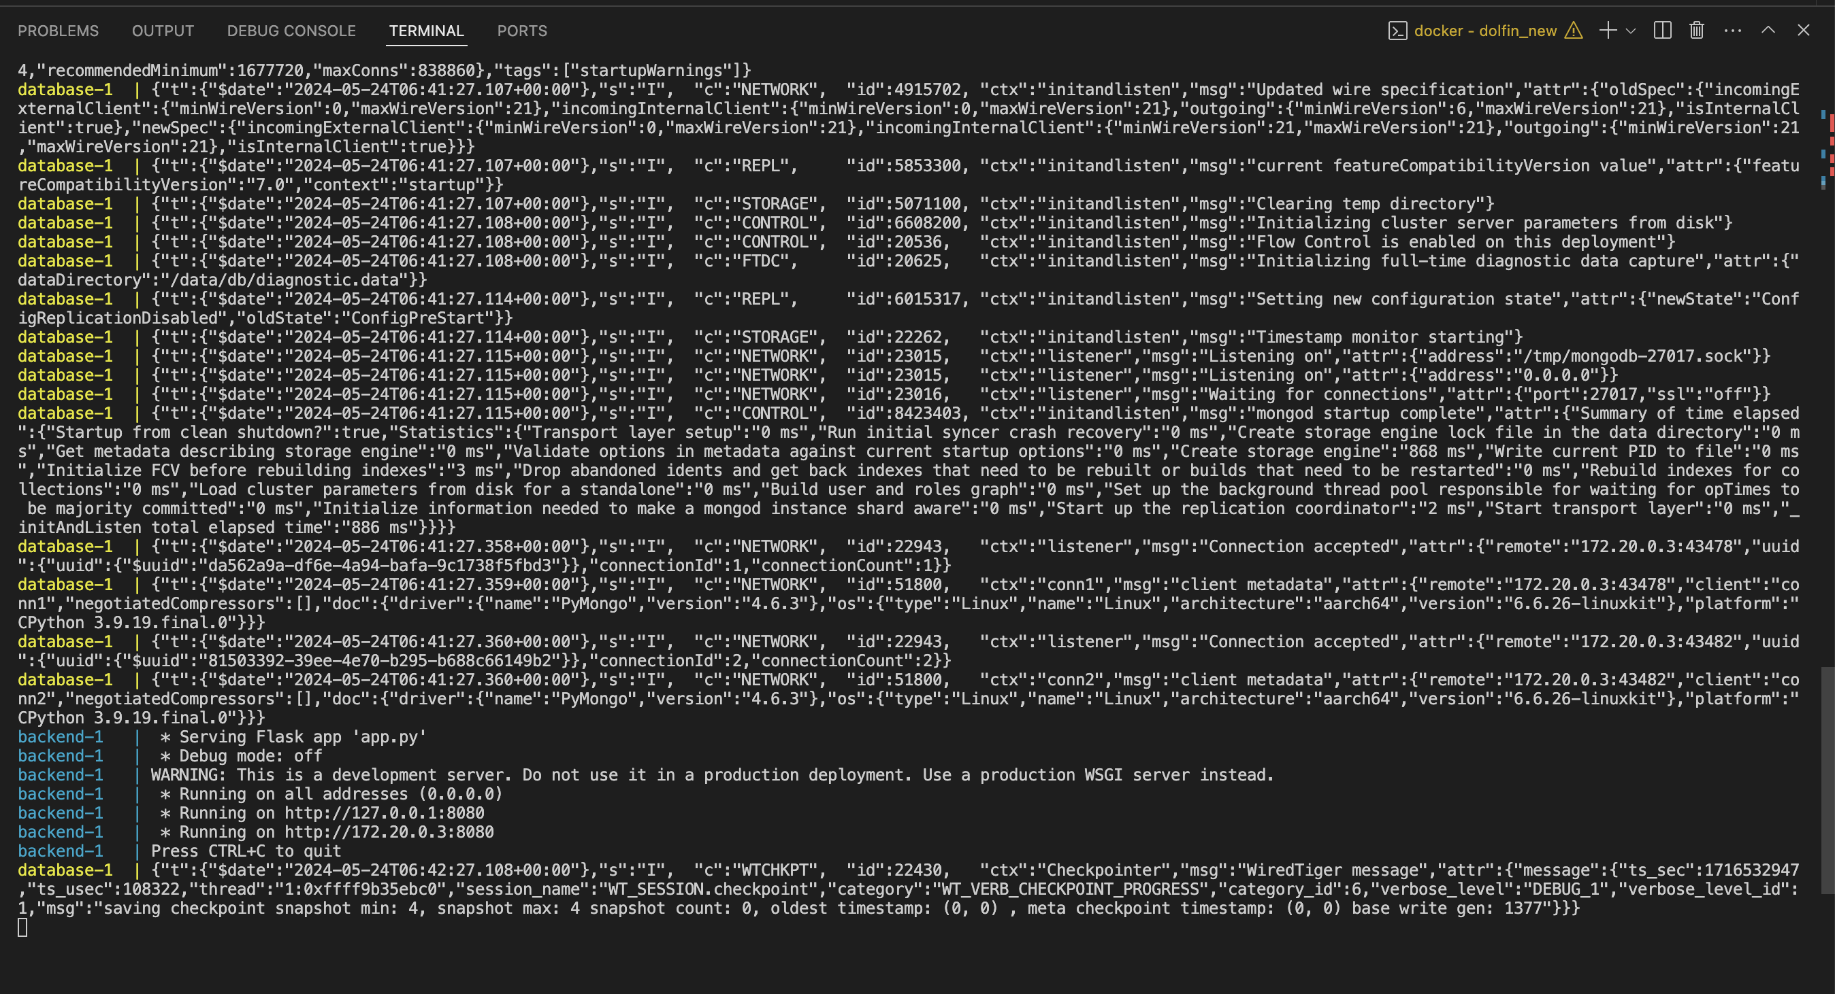

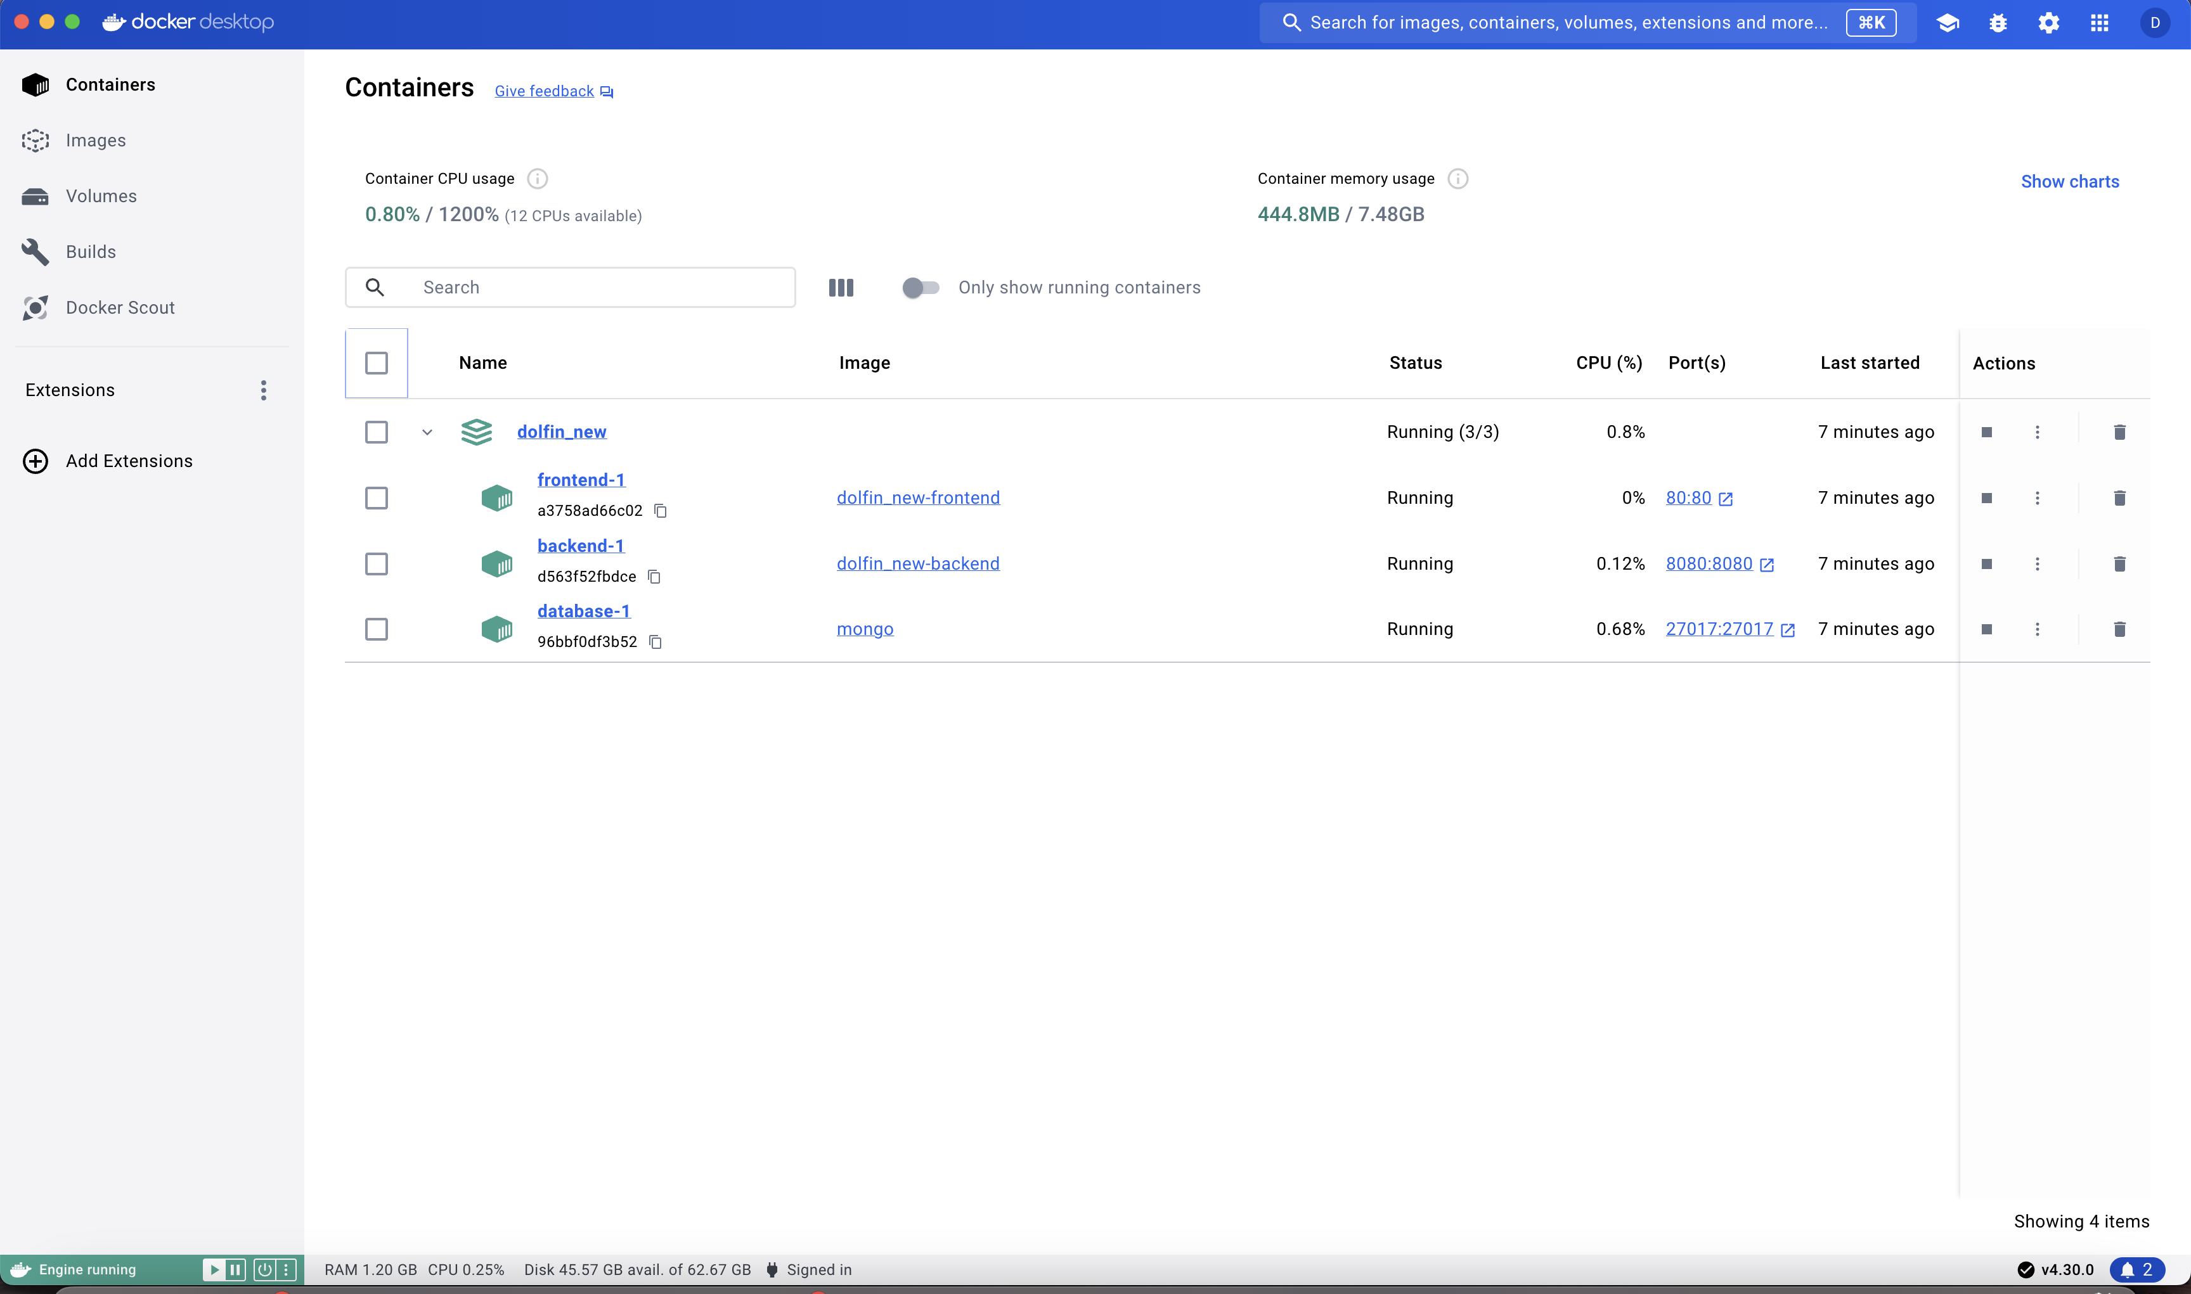

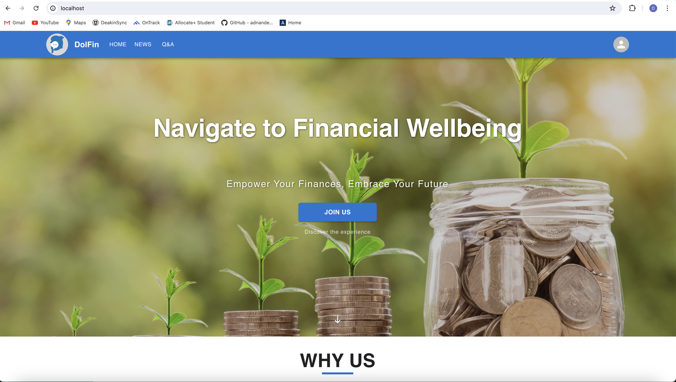

* Developer Envrioment.

Setting up developer enviorment also includes set of steps, we will follow below steps:

**To Check dolfin_server is working**

* Select **Terminal à New Terminal** from the menu.
* If prompted to select a working directory for the New Terminal Window.   
  Select cd Dolfin_new/dolfin_server.
* Create a new Python Virtual environment by entering the following command into the **Terminal Window**.   
    
  **Python -m venv venv**

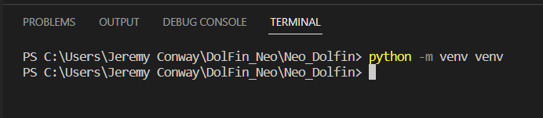

* Activate the **venv** environment by entering the following command into the **Terminal Window**.   
    
  **venv\scripts\activate ( For Windows)**

**source venv/bin/activate (for Mac)**

Note: If you receive an error similar to the one below that indicates that running scripts is disabled on your windows device. Follow the steps shown here:

<https://www.sharepointdiary.com/2014/03/fix-for-powershell-script-cannot-be-loaded-because-running-scripts-is-disabled-on-this-system.html>

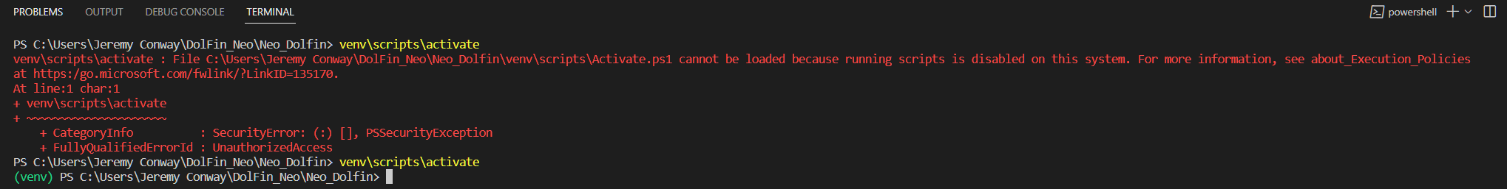

* Execute the following commands in the **Terminal Window** to change directory and install the required libraries.

**pip install -r requirements.txt**

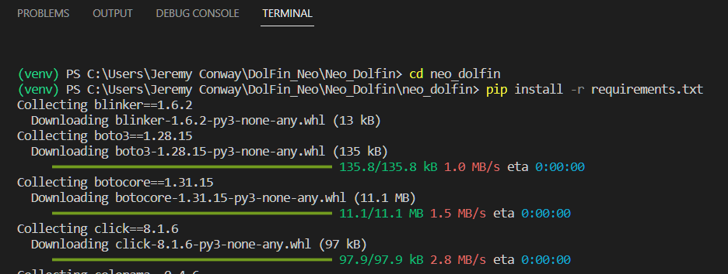

This may take a couple of minutes to download and install all the required libraries/dependencies.

* Execute the Flask application by entering the following command into the **Terminal Window**:

**python app.py**

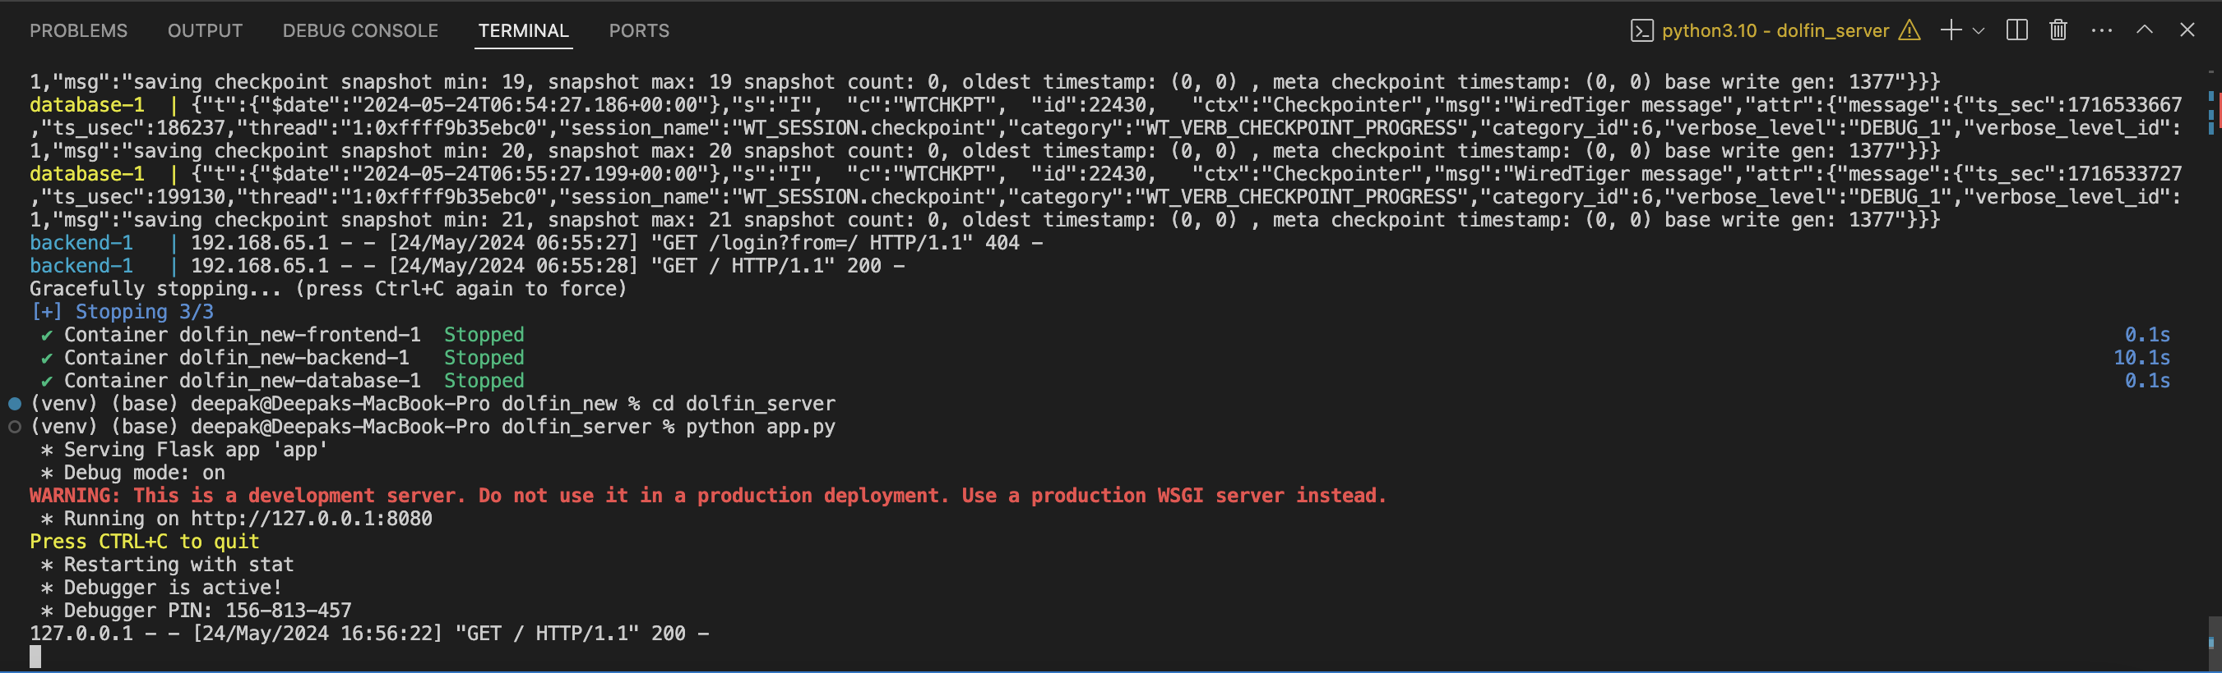

* In a web browser navigate to the following address to access the DolFin Application.  
  <http://127.0.0.1:8080> - this basically tell us the Server is up and running.

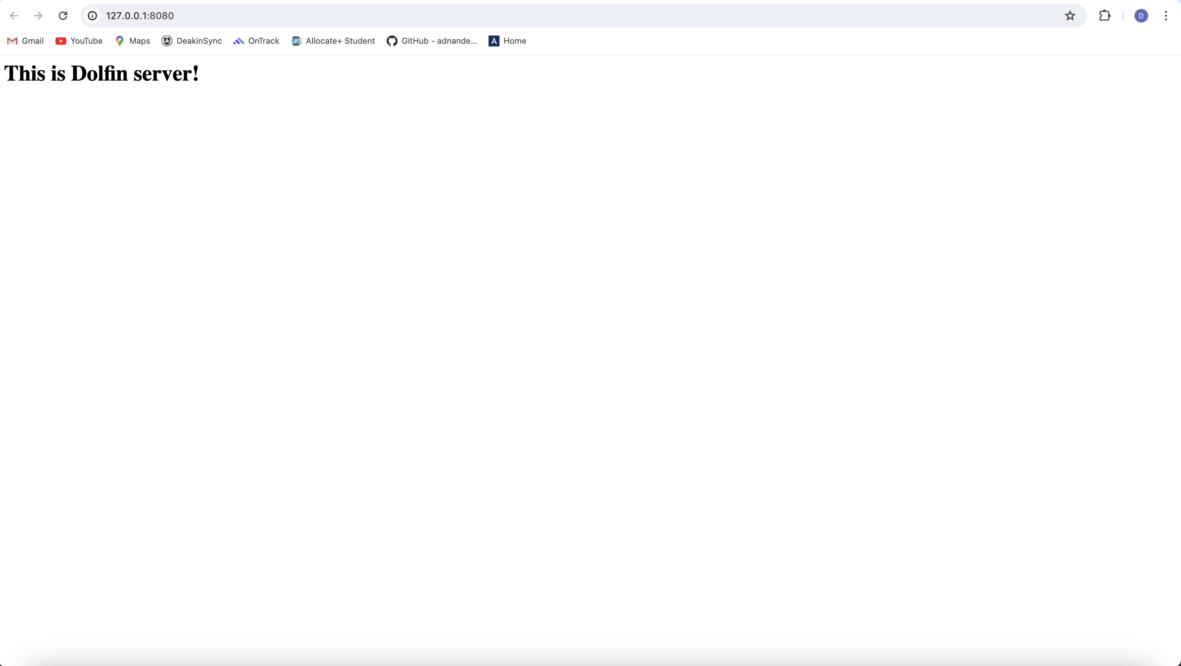

Access the Application using Node:

Navigate to Dolfin_web

Write below commands in Terminal:

Npm install

After installing packages run following command:

Npm run start

It will automatically, take you to the Application homepage:

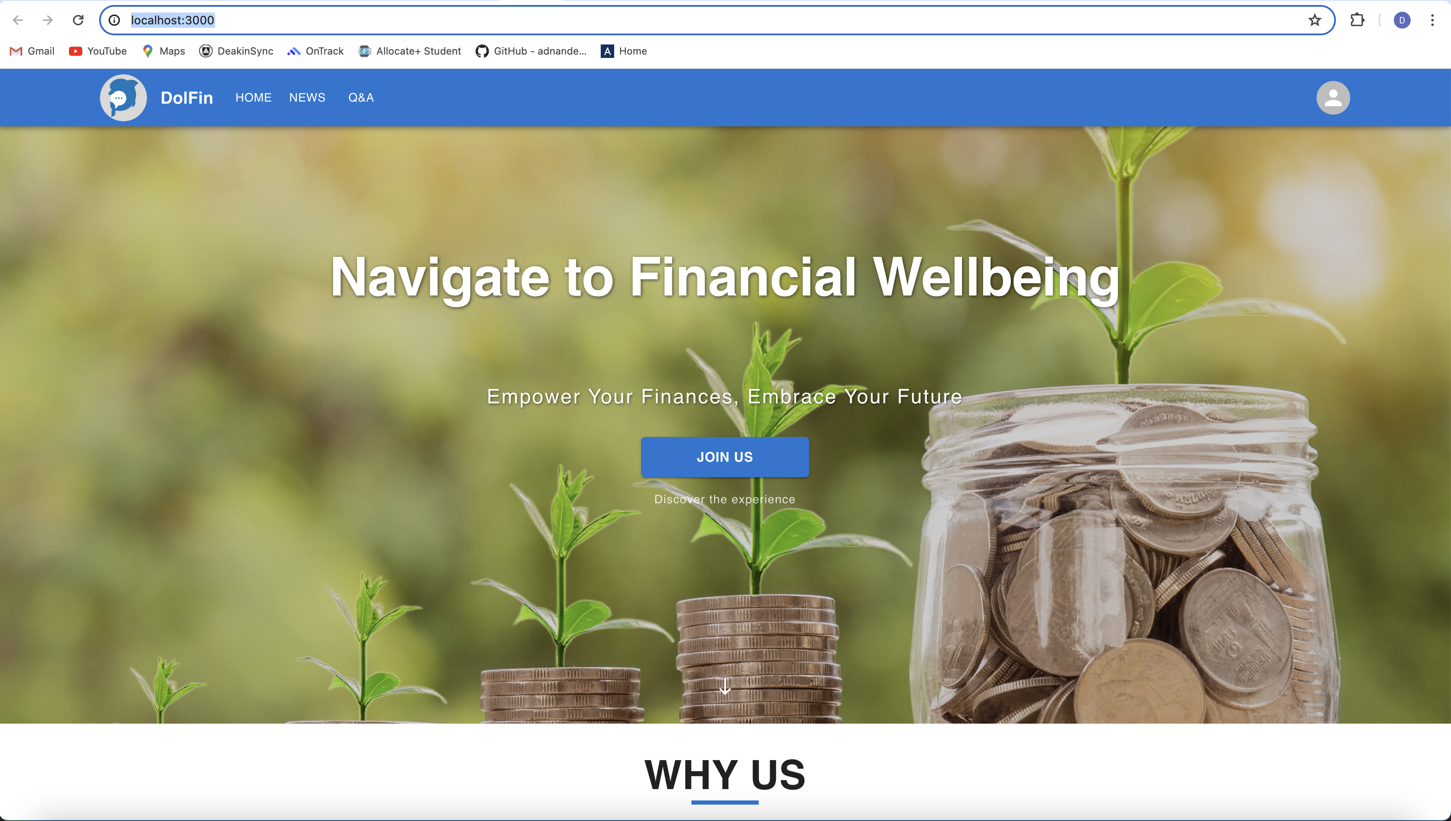

To Interact with Application and Save and Update any Data, Please make sure your Mongo Db Server is on and Connected Locally:

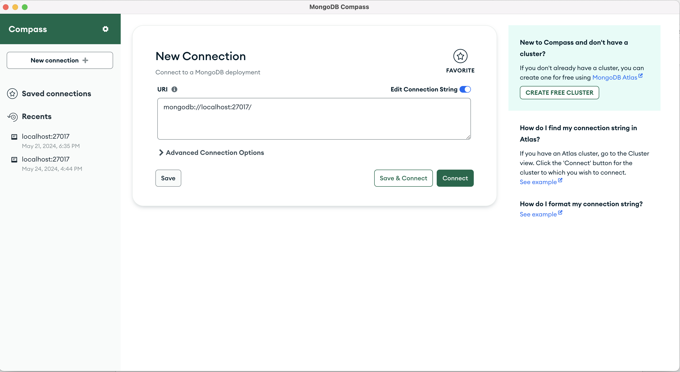

Just Press Connect and you will be able to connect to the Database:

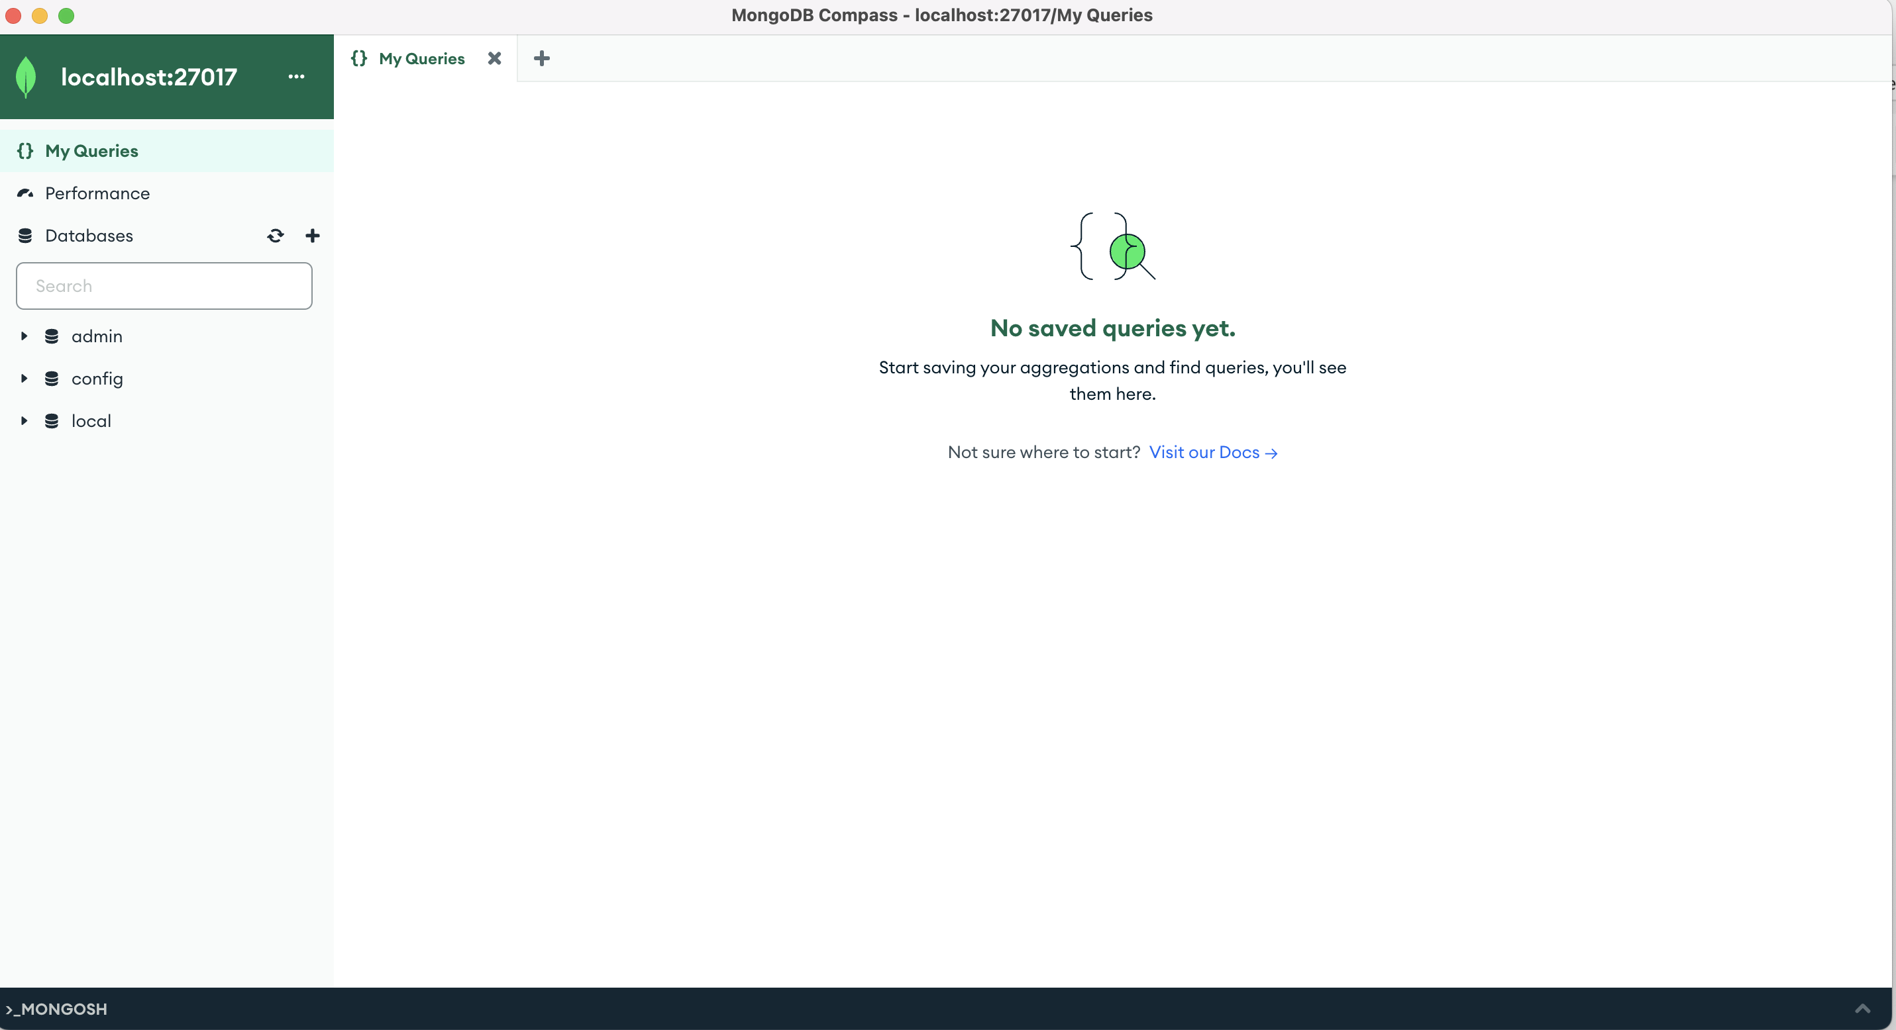

Note: In the example above the port number on the loopback IP address is 8080. This can vary every time you execute the DolFin application on your development device.

# Document Acronyms and References

## Acronyms

The following acronyms or abbreviations were used within this document.

|  |  |
| --- | --- |
| Acronyms | Full Form |
| IDE | Integrated Development Environment |

## References

The following documents, websites or repositories were referenced within this document.

|  |  |
| --- | --- |
| Document | Location |
| DolFin Github Repository | <https://github.com/DataBytes-Organisation/Dolfin_new> |
| 2024-T1 DolFin Handover | [T3 2023 6.5 - DolFin Project Handover.docx](https://deakin365-my.sharepoint.com/:w:/g/personal/mhmohanadas_deakin_edu_au/EbpYs_5Uz3tMpbBgnlFrioUBsRzybtxEX5Lfl3BjvOo7Jw?e=TLOC7e) |